
HWA CHONG INSTITUTION
JC2 Preliminary Examination
Higher 2

CANDIDATE NAME |  |  |  |  |  |  | CT GROUP
CENTRE NUMBER |  |  |  |  |  |  | INDEX NUMBER

GEOGRAPHY  Paper 1  INSERT | 9173/01  23 August 2024  3 hours

READ THESE INSTRUCTIONS FIRST
This Insert contains all the Resources referred to in the questions.

________________________________________________________________________
This document consists of 5 printed pages and 1 blank page

[Turn over
Resource 1 for Question 1

Apple’s supply chain in 2023 and 2024

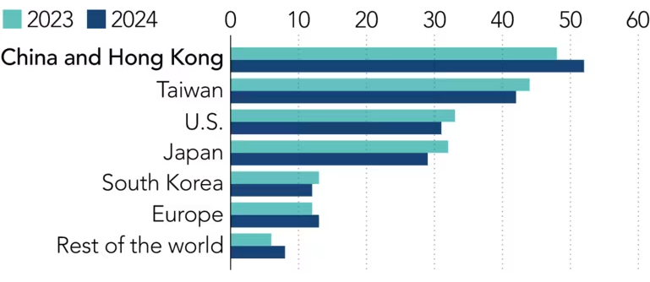

Resource 2 for Question 1

Countries/Territories with Apple stores

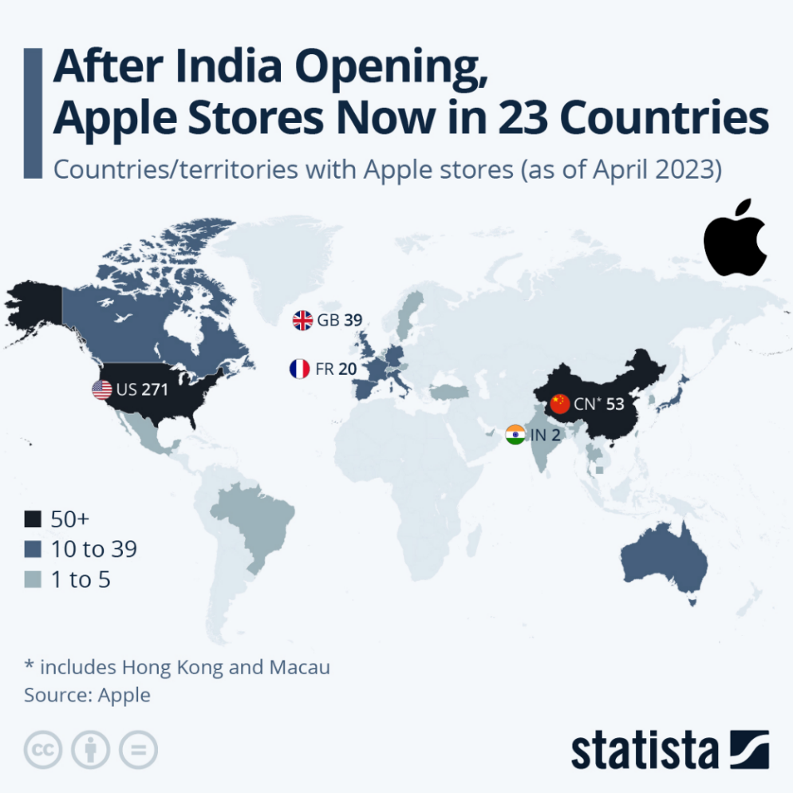

[Turn over
Resource 3 for Question 1

Excerpt taken from business article on WTO and Chinese government’s ‘blacklist’

Complex World Trade Organisation (WTO) regulations will make it very difficult for the US government and major technology companies to take legal action against Beijing’s decision to drop Apple and Cisco from its approved state procurement lists.

When the Chinese government joined the WTO in December 2001, Beijing did not sign up to a *plurilateral treaty on government procurements. As a result, China is able to remove any foreign brands that the government doesn’t like from its state procurement lists with potential WTO blowback.

Virtually all leading tech companies are at risk of being affected, including Cisco systems, Intel, Microsoft and Apple,” said a senior analyst at the Information Technology and Innovation Foundation, a United States-based think tank.

* plurilateral treaty on government procurements refers to the Agreement on Government Procurement (GPA) to ensure open, fair and transparent conditions of competition in the government procurement markets. Not all WTO members are parties to the Agreement.

Resource 4 for Question 2

The classification of deltas
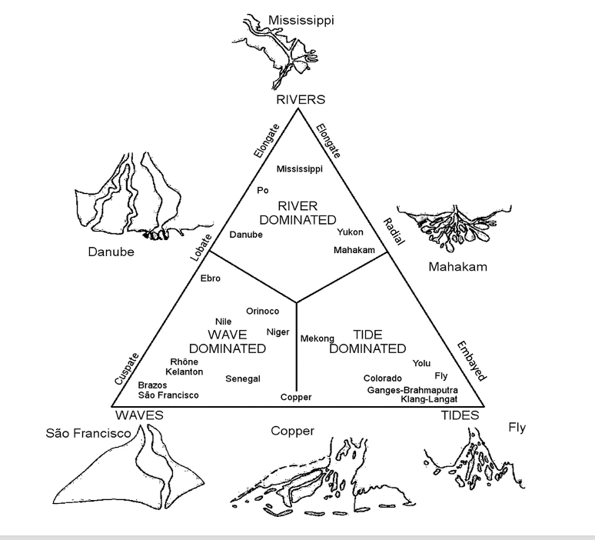

[Turn over
Resource 5 for Question 2

Niger Delta in Nigeria with ecoregions and land use types

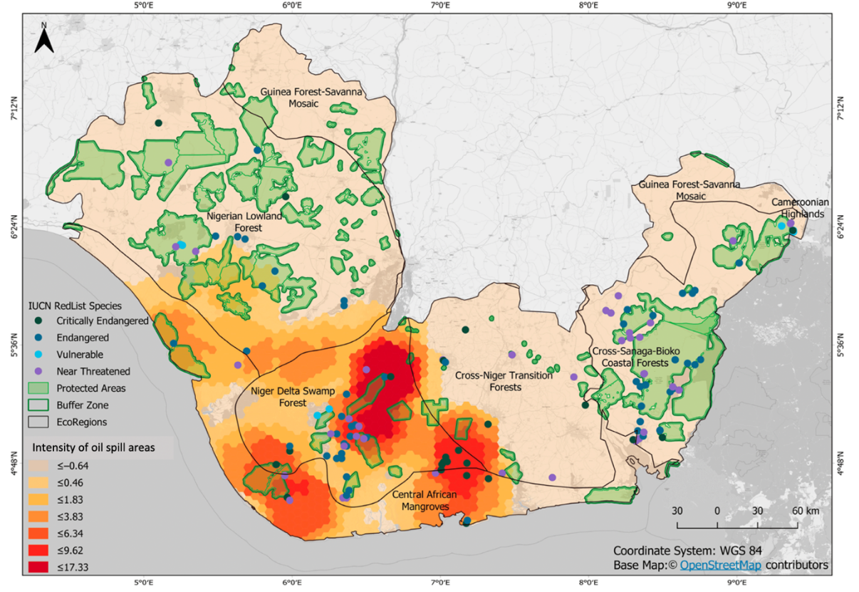

[Turn over
Resource 6 for Question 2

Land use and land cover (LULC) impacted by oil spills in the Niger Delta

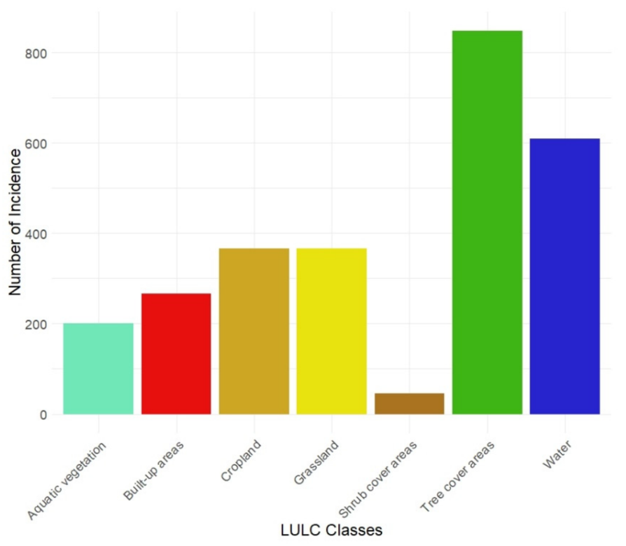

[Turn over

BLANK PAGE

__________________________________________________________________________________________________________________________
Acknowledgements:
Question 1 Resource 1 @ https://asia.nikkei.com/Business/Business-Spotlight/Apple-moves-closer-to-China-despite-supply-chain-shifts
Question 1 Resource 2 @ https://www.statista.com/chart/7974/apple-retail-stores/
Question 1 Resource 3 @ https://www.scmp.com/business/companies/article/1724817/difficult-cisco-and-apple-challenge-chinas-government-
procurement
Question 2 Resource 4 @ https://www.researchgate.net/figure/Classification-of-river-deltas-according-to-processes-dominant-in-shaping-of-
delta_fig1_268693021
Question 2 Resource 5 @ https://www.mdpi.com/2071-1050/14/21/14256
Question 2 Resource 6 @ https://www.mdpi.com/2071-1050/14/21/14256

